**Red Devil Survives Loch Lomond**

**Loch Lomond Waterski Club Charity Ski – Cameron House, 1st January 2017 – in aid of ‘Fastworks’**

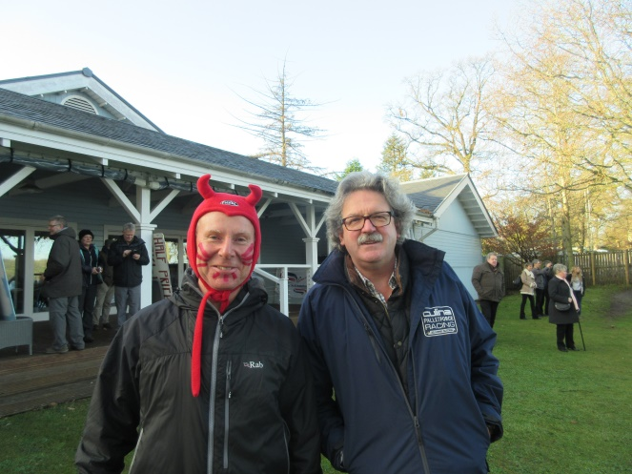 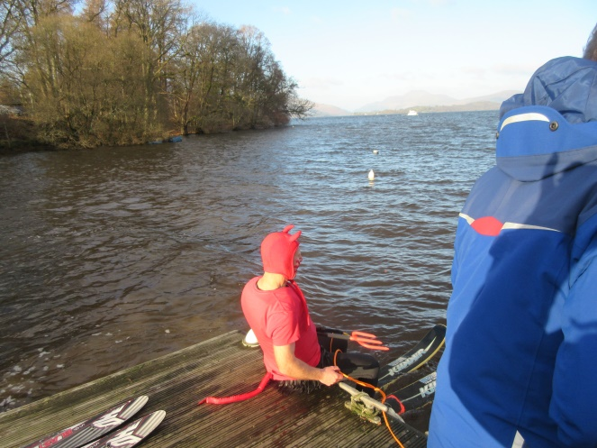

**Red Devil bonds with Stephen**

**A slightly ‘anxious’ wait on the jetty**

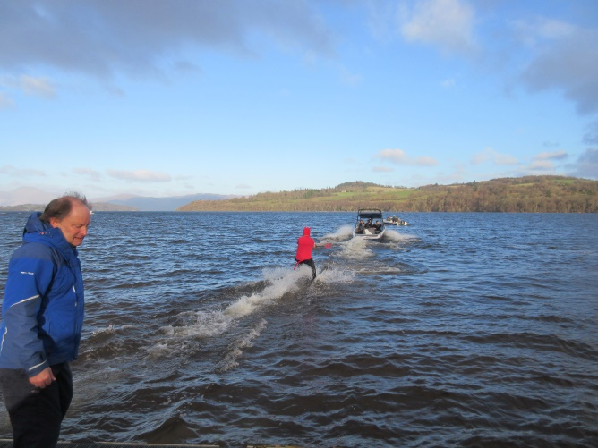

**Phew!.....managed the start**

Campbell (the driver) proceeds like a ‘bat out of hell’. Water conditions much bumpier than they look in the photos. Combined with wake from other boats and the mach1 speed, full focus was on staying upright. One foray outside the wake was enough.

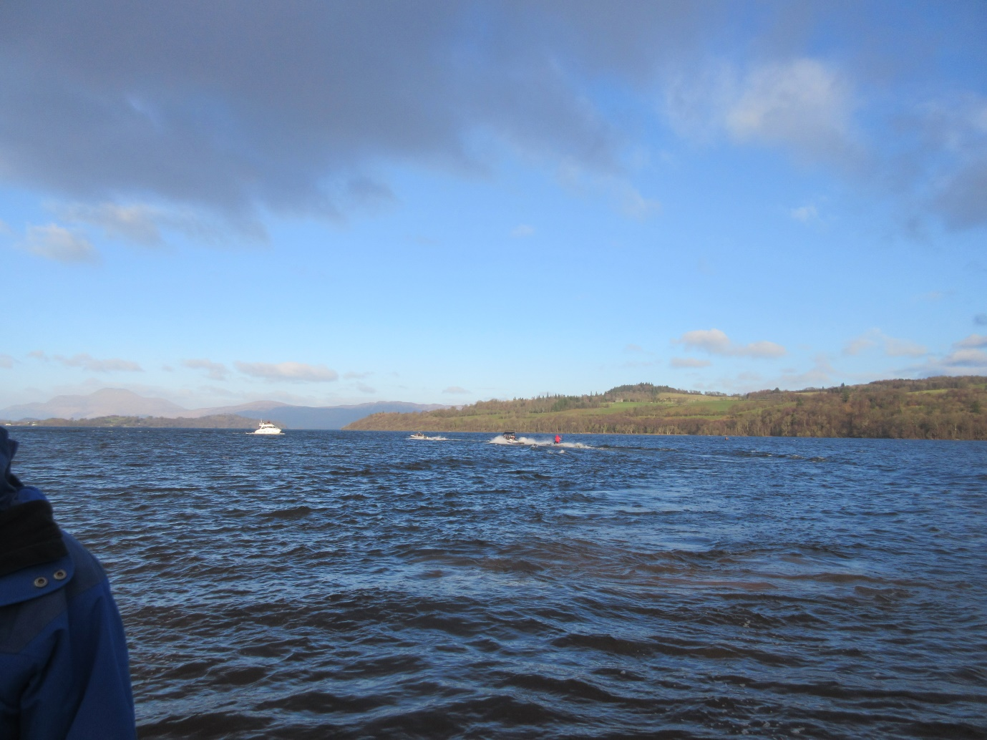

**Off we disappear into the blue yonder**

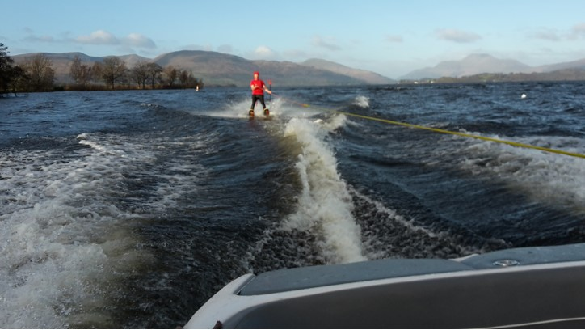

**Wintry sun shines on the Red Devil – good view of snow-free Ben Lomond (far right)**

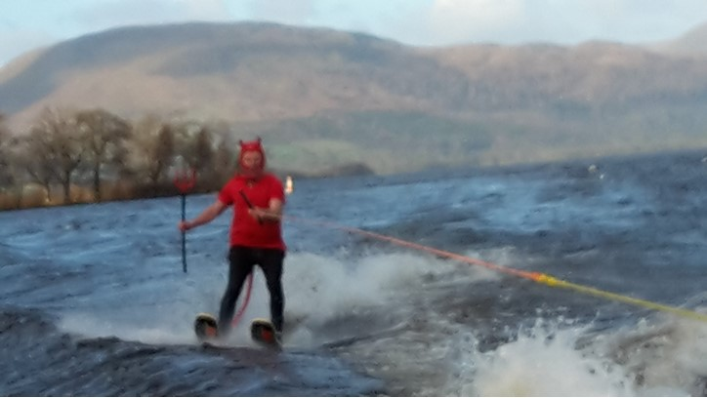

**Near journey’s end**

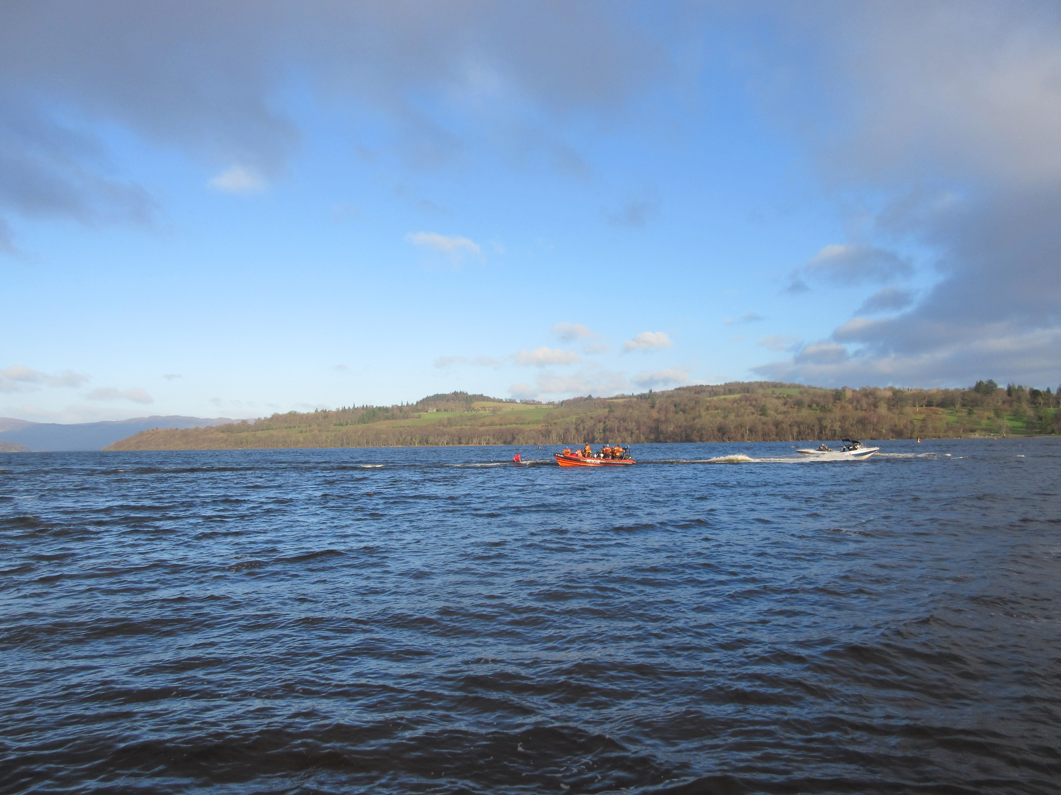

**Postscript**

The New Year’s Day charity waterski event is organised by the [Loch Lomond Waterski Club](http://www.lochlomondwaterskiclub.co.uk/) and has run every year since the early 1980s. A big thank you is due to the members and supporters of the Club who all provide their time on a voluntary basis. For this year’s event particular thanks go to Dave (chief organiser), Campbell (the driver), Stephen, Stuart and Tom. I would also like to thank the highly professional [Loch Lomond Rescue Boat](http://www.lochlomondrescueboat.co.uk/about) team who give up their time to support events such as this, in addition to their main rescue service function on the Loch.

Each year the event helps raise significant sums for charitable causes. Last year just short of £1,000 was raised for Dementia UK. This year’s event is supporting ‘Fastworks’, a locally based charity supporting some of Scotland’s most disadvantaged young children in the Vale of Leven. Affiliated to Save the Children it recently received the ‘UK Community Champion Award’ by Princess Anne.

**Matthew Linning** – Life Member of Loch Lomond Waterski Club

**Sinking into the icy waters of the Loch – just 5m short of reaching the rescue boat**